Name ……………………………………………………………………… Class: ………………………………… Date / /

Objectives: After the lesson the students should be able to:
- Students know that enzymes lower the activation energy for a reaction and that their function depends on their structure.
- Students distinguish between competitive and non-competitive enzyme inhibition.

Activity 1:
Put T in front of the true statement and F in front of the false one:
- Enzymes have no effect on activation energy of the reaction. F
- The structure of an enzyme determines what substances it acts upon. T
- Some enzymes have no effect. F

Activity 2:
What are the difference between competitive and non-competitive enzymes
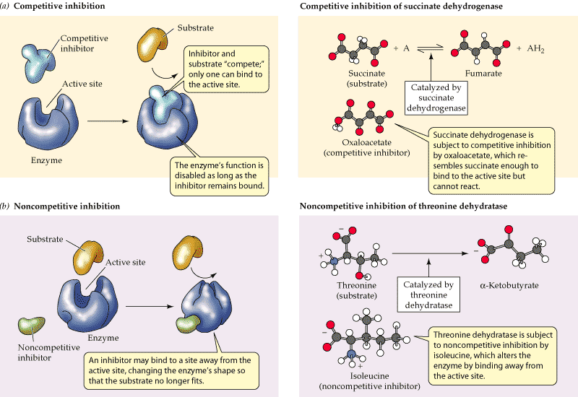

Activity 3:
1-Complete the following table
Enzyme | - Reacts with | - Converting it to
- Salivary Amylase | Starch (Saliva) | Sugar
- Pancreatic Amylase | Glycogen | Sugar
- Lipase | Fats | Fatty acids
      - Any other 4 enzymes from the web.
Homework due date next period
- Draw a diagram to show the lock and key (Mechanism of enzymatic action).
- Using the same drawing illustrate that enzymatic actions are reversible.

توقيع ولى الأمر

